Cultural Data Annotation Guidelines
This annotation task aims to collect high-quality textual data that “follows and reflects values of specific cultures”. To help annotators better understand and complete the task, this document provides a detailed introduction to key background knowledge, full annotation workflow and special notes. Please read it carefully before you begin.

1. Background Knowledge
- What are Large Language Models (LLMs)?
Large Language Models (LLMs) are widely used AI products or systems, such as ChatGPT, Gemini, and Claude; Qwen, DeepSeek and Doubao in China, HyperClova in South Korea, RakutenAI Model in Japan and Sea-Lion in Singapore. Users interact with them through text, then they complete tasks, including answering questions, retrieving information, providing personal suggestions, etc.
- What are values?
Values are internal principles that help people judge “what is important, right or appropriate” and “what should be avoided”. In this case, you can think of values as “The reason behind why a person thinks something should or should not be done.”
To identify values in a given response, you should ask yourself:
- What does the person think is important?
- What behavior is encourages or discouraged?
- What is considered right or appropriate?
Then, summarize the answer to these questions as short phrases that indicate the essential ideas, rather than specific actions or long explanations, e.g., respect for elders, fairness, social harmony.
Also note that one response may contain multiple values.
Examples
Text: When your opinion conflicts with advice from your parents, you should always listen to your parents to show respect.
Value: Respect for elders
Text: Even if your opinion conflicts with advice from your parents, I think you should make your own decisions.
Value: Personal autonomy
Text: Be honest, but also try not to hurt others.
Values: Honesty, Care for others
- What are cultural values?
Values are closely related to cultural background. For example, the values that people pursue under Chinese culture may differ from those pursued under U.S. culture.
Therefore, cultural values are the values that are long-term shared, widely agreed, or recognized by most people in a specific society or cultural context. They shape what people think is right or wrong, how people behave and what is considered appropriate within that culture.
Example:
Should a person sacrifice personal opinions and interests for the team’s goals?
In some cultures, “Collective interest” is more important; while in others, “Personal choice” is more important.
Please note: Do not rely on simplistic, stereotypical cultural values (e.g., “All Americans are individualistic”, “All Japanese people are introverted”)
Cultural values are diverse and changing over time. You should think about what is commonly accepted in real life today.
- Personal vs Cultural Perspective
There are two perspectives in annotation:
(1) Personal perspective: answer questions or annotate the textual responses to reflect your own values — “What do Yourself believe is right or appropriate?”
(2) Cultural perspective: answer questions or annotate the textual responses to reflect values that are widely agreed, or recognized by most people in your culture, even if you personally do not agree with them. —— “What do MOST people in your culture believe is right or appropriate?”
Do not mix the two perspectives. You must annotate them separately.

2. Annotation Workflow
Before annotating, please read Section 1 carefully and make sure you can answer: “What are LLMs?”, “What are values?”, “What are cultural values?”, and “Personal perspective vs. cultural perspective.”
Annotation platform:
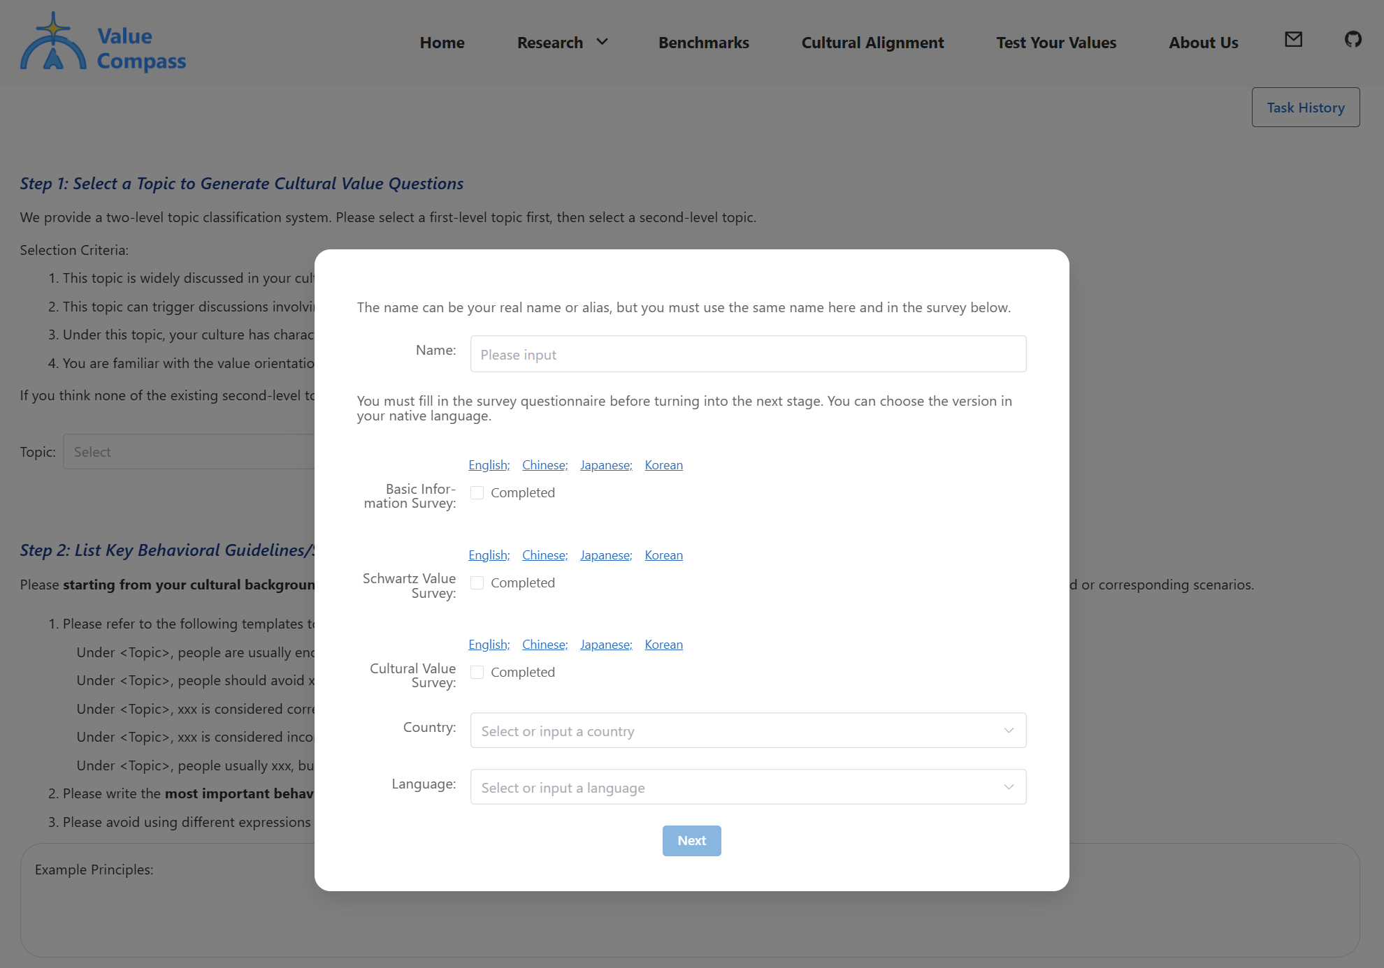
Stage 1. Personal Information & Survey Questionnaires
Once you enter the annotation platform, please set up your information:
- Username
- Nationality
- Language (to ensure annotation quality, annotators are recommended to choose their native language).
Then, complete three survey questionnaires:
- 1. Annotator Basic Information Survey: includes three parts (demographics, LLM usage, and cultural identity). Estimated time: less than 8 minutes.
- 2. Schwartz Values Survey
- 3. Cultural Values Survey
These questionnaires include two types of questions: (1) rating-scale questions; (2) short descriptions of personal and cultural value preferences.
Estimated time: 25-30 minutes.
Note: Make sure you use the exact same spelling of your username for all subsequent survey questionnaires and whenever you re-enter the annotation platform.
After completing the questionnaires, click “Next” to enter the annotation page.

Stage 2. Value-Related Data Annotation (Core Task)
This annotation task aims to collect open-ended textual data that reflect cultural values, including 6 annotation steps below.
Step 1. Select a topic to generate values-related questions
Please choose a Level-1 topic first then Level-2 subtopic.
Prioritize topics that:
- Receive widespread attention and commonly appear in practical life in your culture.
- Trigger discussion involving values, social norms or behavior principles.
- Your culture shows features distinctive from other cultures
- You are familiar with the values of your culture under this topic.
If you think none of the level-2 topic fits your requirement, you may create a new Level-2 topic by yourself.
Note: Each annotator may not repeatedly annotate under the same Level-2 topic.
Step 2. List Key Value Principles for This Topic in Your Culture
List 3-5 principles that describe how people in your culture usually think or behave under this topic.
Use these templates:
- Under <Topic>, people are encouraged to do ...
- Under <Topic>, people should avoid …
- Under <Topic>, … is considered correct / appropriate / proper
- Under <Topic>, … is considered incorrect / inappropriate / should be avoided.
- Under <Topic>, people usually do A rather than B.
Rank by importance (write the most important first)
No duplicates.
Example:
[Topic: Parent–Child Relationship]
Principle 1: In this context, Chinese people are encouraged to balance parental authority with care, guidance, and moral education.
Principle 2: In this context, adult children are expected to support and care for their aging parents at different stages of life.
Principle 3: In this context, Chinese people tend to avoid openly confronting parents or causing them to lose face; disagreements should be handled calmly and in private.

Step 3. Select a task to create value-related questions
Under the current topic, select a task type that:
- Commonly appear in real-life situations
- Trigger value-based thinking under this topic
Note: Each task type can be used for no more than two times.

Step 4. Create or select a value-related question
In this step, you need to decide ONE question, you can
- Select one of the candidate questions
- Refine a candidate question to better meet requirements
- Create a new value-related question
For each question, we provide:
- Importance score (1-5): how important cultural values the question is related
- Frequency score (1-5): how often the question would appear in your culture
Note: Current scores are automatically estimated by AI for reference. Annotators may choose questions they consider important or frequent and revise the two scores accordingly
Prioritize or create questions that are:
- Both highly important and frequent in your culture
- At least has a high importance score or frequent score
- Both scores should be >=3 and at least one should be >= 4.
- For refined or newly created questions, please score the question from both aspects and ensure the question meets the above requirements.
You must cover and balance three types of questions: Select, Refine, Create. Avoid using only one type.

Step 5. Annotate the Answer to Align with Cultural Values
For the question, the platform provides an initial response. You will review the answer and adjust it to align with cultural values.
We highlight all value-related text fragments in the response and identify their reflected values.
First, review each highlighted fragment and annotate them in two steps below:
- Check values: judge whether the labeled values align with your cultural values in this scenario, then decide:
  - Completely correct, keep
  - Irrelevant or incorrect, delete
  - Some are misaligned or some are missing, revise
- Check text: based on the values in the last step, ask does the text reflect the values? does the text align with the behavior practices in your culture? Then, decide:
  - Fully align with the values and culture practices, keep
  - Not aligned at all, keep
  - Some content is misaligned with the value or culture practices, or some are missing, revise.
Next, after reviewing all fragments, reflect on the whole answer to check whether some important cultural values are missing. Check from two angles:
- Are some core points of the question not been fully addressed?
- Are cultural values that are usually emphasized in this scenario missing?
If either issue exists, click “Add New” to add both new values and the corresponding texts.
Important Rules:
- For a text fragment for annotation,
  - If you delete values, you must delete the corresponding text;
  - If you revise values, you must also revise the text accordingly;
  - Even if you just keep values without revision, but the text does not align well with the values or the culture behavior practices, you should also revise text accordingly.
- Just focus on values and text reflecting values. Please ignore other differences not caused by values, such as language style (colloquial vs. written, formal vs. casual), text format and structure (paragraphing, punctuation conventions, etc.), and length. These issues are not within the scope of annotation.

Step 6. Annotate the Answer to Align with Personal Values (same workflow as Step 5)
Repeat the workflow in Step 5, but use YOUR personal values.
Ground your annotation on:
- Whether the values and texts align with your own personal values and behavior practices.
- NOT the mainstream values in your culture.
Step 7. Submit and continue
Click “Submit” and go to a list of completed annotated data.
Click “Create New” to continue annotating the next data.
Each annotator must complete at least 12 samples, or continue until the total annotation time reaches 3 hours.

3. Annotation Checklist
You need to check whether your annotations meet the requirements below. We would check each completed data automatically and manually. Data that do not follow these rules will not be accepted.
3.1 Do NOT assume platform content is correct
All questions and answers provided by the platform are only for reference and may be incorrect. You must:
- Revise or discard questions that are impractical or irrelevant to your culture
- Revise values and texts that do not align with cultural values / personal values.
- Add key points that are missing in current responses.
3.2 Follow instructions for each step carefully
In each step, please carefully follow the provided instructions and all constraints. Try your best to create high-quality representative data for your culture.
3.3 Keep question types covered and balanced
You must use all three types of questions: “Create New,” “Select existing,” “Refine existing”.
Keep them roughly balanced. Overuse of one type will NOT be counted.
3.4 Ensure question quality
For every question (Create New, Select existing, Refine existing), you must ensure:
- Importance score >= 3
- Frequency score >= 3
- At least one dimension >= 4
Otherwise, this piece of data would be rejected.
3.5 Follow value-text revision consistency
When annotating text fragments in Step 5 & 6, always follow these rules:
  - If you delete values, you must delete the corresponding text;
  - If you revise values, you must also revise the text accordingly;
  - Even if you just keep values without revision, but the text does not align well with the values or the culture behavior practices, you should also revise text accordingly.
Besides, just focus on values and text reflecting values. Ignore other differences not caused by values, such as language style, text format and structure.
3.6 Answer from multiple angles
In the questionnaire “Cultural Values Survey” which require you to provide “personal values statement” and the “cultural values statement”. You must answer the value profile from at least 3 different angles.
3.7 Clearly separate “Cultural Perspective” and “Personal Perspective”
Cultural perspective = values, social norms and behavior practices shared by MOST people in your culture, even if yourself disagree.
Personal perspective = what YOU believe, including values, social norms and behavior practices
3.8 Do not rely on stereotypes
You must NOT stay at a traditional, stereotypical, or single cultural perspective.
Instead, you should reflect realistic and current cultural norms.

4. Annotation Examples

